Functional Safety

Consider risks involved in systems. Safety standards tend to be Industry Specific, which means that only those in the industry tend to know the minutia of details associated with the industry safety standards.

Functional Safety – exits to ensure the functions of a device do not lead to injury/harm.
- created to reduce the risk associated with the use of devices

Automotive functional safety was developed out of the increasing use of complex hardware and software systems for control systems.

The most generic standard is IEC 61508, which exists as an IEC/ISO safety publication.
It covers general functional safety for a number of industries.

ISO 26262 (offshoot of IEC 61508) specifically applies to automotive passenger vehicle electrical and electronic systems.

Functional Safety Lesson encompasses both FUSA and also the Saftey of the Intended Functionality (SOTIF).

Functional Safety is just one part of the overal automotive safety.

Automotive Safety versus Automotive Funcctional Safety

Vehicles have systems that include hydraulic, mechanical, electrical, electronic, and chemical.
The Society of Automotive Engineers website has examples of various automotive standards covering topics about safety and design best practices.

Different Governments have their own saftey standards, and even the United Nations have a World Forum for Harmonization of Vehicle Regulation.

Functional Safety specifically only looks at electrical and electronic system malfunctions.

Functional Safety doesnt look at nominal performance.
Example: Nominal Perfromance of an automatic braking system could be that a vehicle traveling 60 miles per hour should come to a complete stop in 5 seconds. This is not something functional safety determines.

Instead, functional safety would look at malfunctions like enganing the braking function when it isnt supposed to, or if the system brakes too hard causing injury to the driver. Nominal Performance is not a part of the functional safety standard.

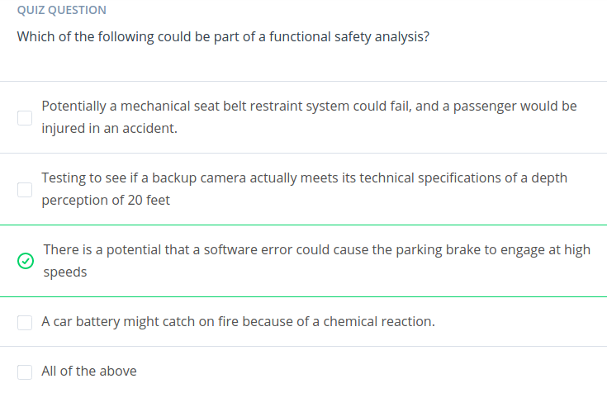

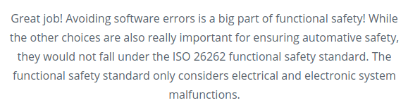

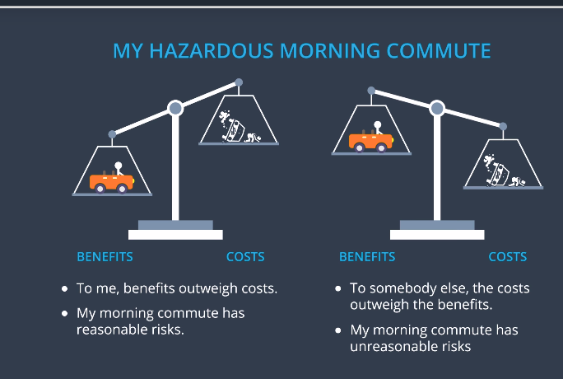

Different people have different conclusions to their risk analysis.

What is Functional Safety?

The idea of Functional Safety is to:
1) Identify high risk situations and then,
2) Lower risk to reasonable levels

Saftey is equal to the absence of unreasonable risk.

There are 3 main steps to functional safety analysis.

1) Identify Hazards, In a passenger vehicle’s electronic system that could cause physical injury or damage to a person’s health

2) Measure/Evalute the risk, of the hazardous situation so that we know how much we need to lower the risk.

3) Via Systems Engineering, prevent accidents from occurring by lowering risk to reasonable levels. Systems engineering helps you figure out what your vehicle needds to do and what your vehicle design needs to look like in order to remain safe/ or as safe as possible.

Lowering risks invovles designing safe systems, testing your systems, and documenting our desings and tests.

What level of risk is reasonable?

Risk is never entirely eliminated, only reduced to a level acceptable by society as a whole.

Example. Previously seatbelts were not required in vehicles, and was accpetable by society’s standards, howevery nowadays, it is an unreasonable risk.

Functional safety focuses on keeping risks below society’s current threshold. (Remember Functional safety deals with electrical and electronic systems)

Eliminating Risk Completely would paralyze engineering, product development and testing. It is impossible, on the other hand, not eliminating enough risk leads to failed products, recalls, lawsuits, or even loss of life.

The term Functional, comes from a branch of system engineering called requirements engineering.
Systems engineering seperates requirments into:

Functional Requirements – what your system is supposed to do; how the systems functions

Non-Functional requirements – how the system should behave; how relibale is the system.
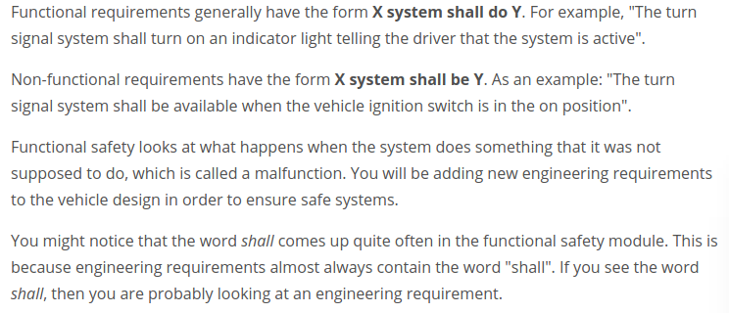
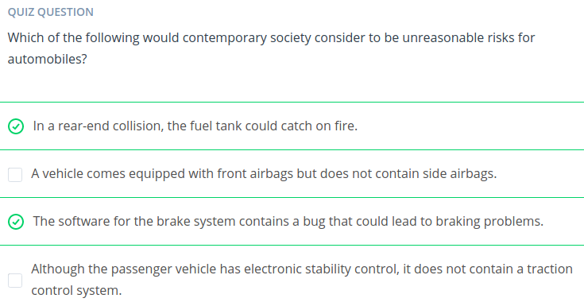
Identifying Hazards

Many saftey features like headrests and windshield glass was created because there used to be injuries caused without them.
However, we want to Identify Hazards before they ever cause accidents.

The real answer is it takes Brainstorming. You generally should take a cross section of personel from different roles in your company to help brainstorm possible hazards.

The General Causes of Accidents are:

1) Errors caused by humans (ex. Most car accidents)
2) Errors from Technology (Software bugs in cars)
3) Errors from Human-Technology interaction (Ex. Advanced driver assistance systems)

Errors and Self-Driving Cars

One of the aims of self-driving cars is to take humans completely out of the equation, which would lead to a tradeoff that autonomous vehicles could introduce more technology errors.

Ex. Relying on machine learning algorithms that dont have a training set of pedestrians in wheel chairs. It would not be classisfied as a pedestrian. How accurate do our results need to be on a validation set? Who determines what the training set needs to contain?

Autonomous vehicle tech is so new that standards like ISO 26262 dont consider issues related to self-driving cars like machine learning algorithms. But the principles of functional safety, which uses systems engineering to identify and lower risks, apply to autonomous vehicles as well.

Intro to Evaluating Risk

Every hazard has a risk associated with it, and as Functional Safety Engineers, you should define risk numerically.

Risk = Severity of Harm (How bad is the injury) x Probability of Occurence (Frequency of a driving situation)

Things like the probability of your brakes failing are not included in the Probability of occurence. Only driving situations are considered.
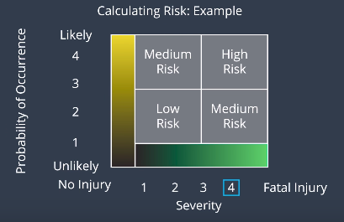

High risk requires enough testing to bring it down to accpetable levels.

ISO 26262 defines risk factor as ASIL – Automotive Safety Integrity Level, which is a 4 point scale of ASIL A, ASIL B, ASIL C, and ASIL D which is the highest risk.

There is also a level below ASIL A called QM – Quality Managed, meaning that development according to accepted quality principles is sufficient to reduce risk.

Into to Systems Engineering

- A construct or collection of different elements that together produce results not obtainable by the elements alone.

Steps:
1) Requirements Engineering: Figure out your vehicle needs to do
2) System Architecture Design & Allocating Requirements
3) Testing and Verification
4) System Integration

Example:
For a Lane Departure system that warns the drivier by vibrating the steering wheel.
We see the requriment should be that the vibrations aren’t enough to let the driver lose control of his vehicle. We can solve this by creating the requiremnt that if the vibrations reach a certain threshold, that the lane departure warning should just stop.

We can allocate that design requirment as part of the system desing plan, and test to ensure that the lane departure warning stops when vibrations reach a certain threshold.

The V Model

To organize a system analysis, system engineers use what are called process models. These process models provide a framework for conducting a methodical systems analysis. ISO 26262 uses a process model called the V Model.

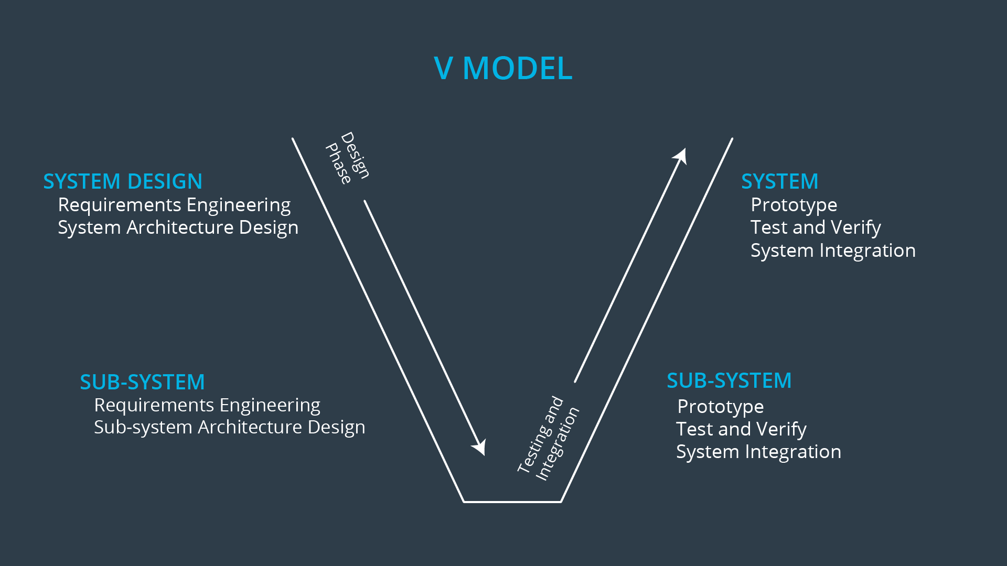
Left side is the design phase of the model.
Right side is the testing, verification, and integration.
Top is the itegrated systems.
Bottom is the Sub Systems.

As you traverse down the V, you focus on smaller and smaller subsystems.

Combine both sides to compare results to your desing requirements at the end.

Two other proper process models are the Spiral Model and the Waterfall model.

